Annual Report 2021
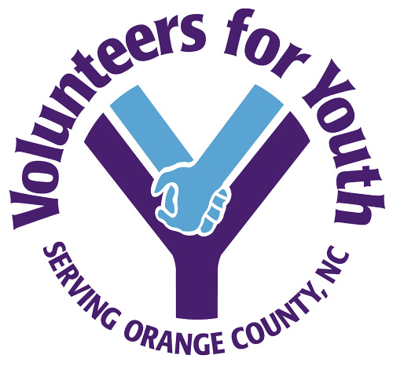

Mentoring – Community Service – Teen Court. Three different programs with one common aim: connecting disengaged young people with their community and helping them make responsible choices.
For nearly 40 years, Volunteers for Youth has worked to make a difference in the lives of Orange County children and youth. With a focus on children and teens who are at risk of being failed by the community, Volunteers for Youth provides guidance to young people in need of a helping hand.
In 2021, our country faced the extraordinary challenges of dealing with a pandemic while coming to terms with centuries of institutionalized racism. Meeting the needs of children and youth at such a time has not been an easy task. With the help of dedicated employees, board members, volunteers, and community partners though, the three core programs of the organization continue to bring needed services to even more local youth.
MENTORING
Volunteers for Youth operates Orange County’s longest running mentoring program. Mentoring is the organization’s original, signature program. Research shows that mentoring is an effective means of promoting positive behavior. Thousands of children matched with mentors through Volunteers for Youth are living proof that mentoring works.
In 2009, Volunteers for Youth formed a mentoring partnership with the SMART project, a UNC Buckley Public Service Scholars program. Through this partnership, 205 UNC students have been matched one-on-one as mentors to 205 local children who could benefit from time with a caring mentor. As participants in a fall and spring semester sociology class, the SMART mentors commit to spending the entire academic year with their young “mentees.” For the first half of 2021, these relationships were forged virtually, via social media, telephone, and mail. In the fall of 2021, we started a new academic year with a welcome return to face-to-face mentoring.
To expand the reach of our mentoring efforts, Volunteers for Youth’s mentoring program includes group mentoring. A group at Smith Middle School brings primarily female students together weekly and is designed to empower its members and set them on a path to future success. Led by Abby Gillis and Tamiya Thomas, group members participate in fun activities that help them explore the challenges of growing up and how to make wise choices when faced with those challenges. Due to COVID restrictions, the meetings currently take place outdoors but are nonetheless well-attended
Along with SMART mentoring and group mentoring, Volunteers for Youth continues its traditional community mentoring program, matching trained volunteers with children who could benefit from positive adult role models. In 2021, 14 community mentors were paired one-on-one with 14 local children. Through shared experiences such as exploring the community, learning new skills, and attending live performances and sporting events, the mentors and youth developed strong relationships.
Executive director Susan Worley and group coordinators Abby Gillis and Tamiya Thomas facilitate the mentoring program at Volunteers for Youth.

JUVENILE COMMUNITY SERVICE AND RESTITUTION
Volunteers for Youth oversees the community service work of all young people in Orange County who are assigned community service by the courts after being charged with a legal offense. Volunteers for Youth recruits nonprofits throughout the county to serve as work sites for the program, where volunteer supervisors evaluate and manage the youths’ work. By completing community service hours, program participants learn valuable work skills and accountability for their actions. Thirty-six young people participated in the program in 2021.
Because of COVID concerns, many community service work sites were temporarily closed in 2021. To help youth complete their hours, Volunteers for Youth created a packet of in-home options. The opportunities included making videos about social justice issues, assisting elderly neighbors with yard work, and creating video diaries about the personal impact of the pandemic. Program coordinators also brought together limited groups of youth to participate in free neighborhood car washes, yard clean-up projects, and workshops addressing issues of racism.
Scott Dreyer and Madison Bennett coordinate the community service program at Volunteers for Youth.
TEEN COURT
Teen Court is an alternative court program for young people who have committed minor offenses and are referred from law enforcement, juvenile services, or the schools. The youth are tried and sentenced by a jury of their peers, with other teens playing the roles of defense attorney, prosecutor, and other court officials. Teen Court is run by young people and provides hands on opportunities for teens – both defendants and volunteers – to gain insight into the legal system while also learning from their mistakes and gaining valuable life skills along the way. Positive peer pressure helps participants learn to accept responsibility for their actions and then pay back their community through community service and other sentencing. The program served eleven youth.
Along with the teens who run the program, several adults are in the courtroom to lend advice and to supervise activities. Jamella Smith and Madison Bennett, the program coordinators, are assisted regularly by volunteer attorneys. UNC law students coach and mentor the teen attorneys and the courtroom is monitored by a deputy from the Orange County Sheriff’s Office.
Changes brought about by COVID were a challenge for teen court in 2021. For a portion of the year, the courthouse where the program normally takes place was closed. Teen court personnel took this as an opportunity to evaluate ways to improve the program and incorporate more restorative justice practices into the programming.
Jamella Smith and Madison Bennett coordinate the teen court program at Volunteers for Youth.

Making a Difference!

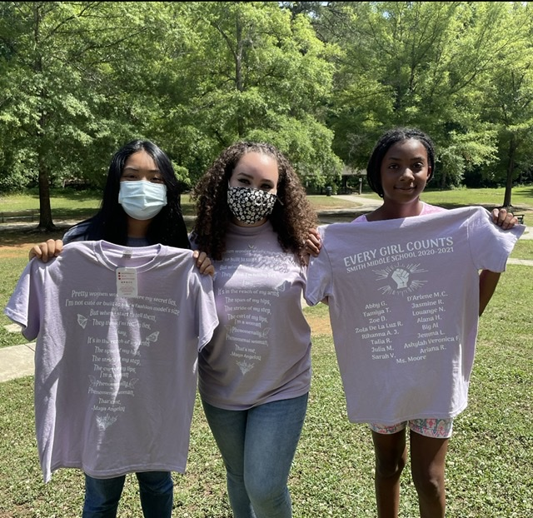

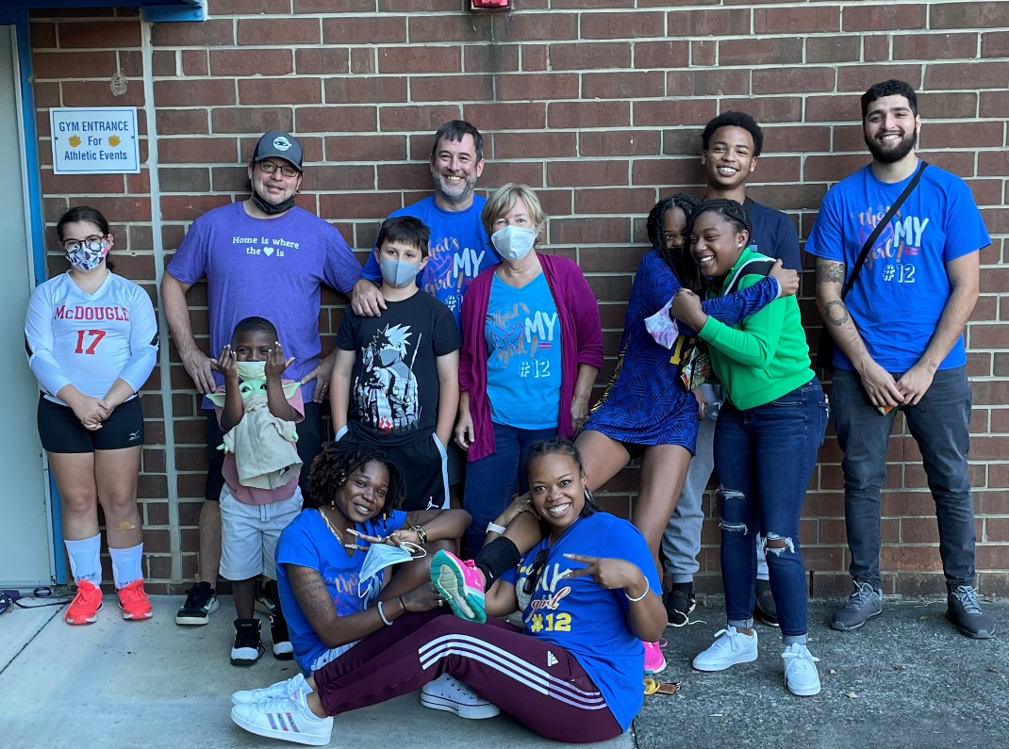

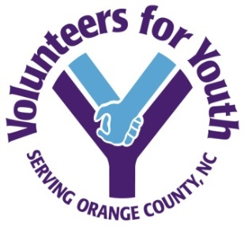
2021 Board of Directors and Staff
Board of Directors
Chris Blue, President
Chandler Burns, Treasurer Melissa Payne, Secretary
Jared Cates Andy Chacos Paul Connell Jason Freeman Tim Hucks Skye MacLeod Mario Meeks André Richmond Rick Steinbacher Shilanka Ware

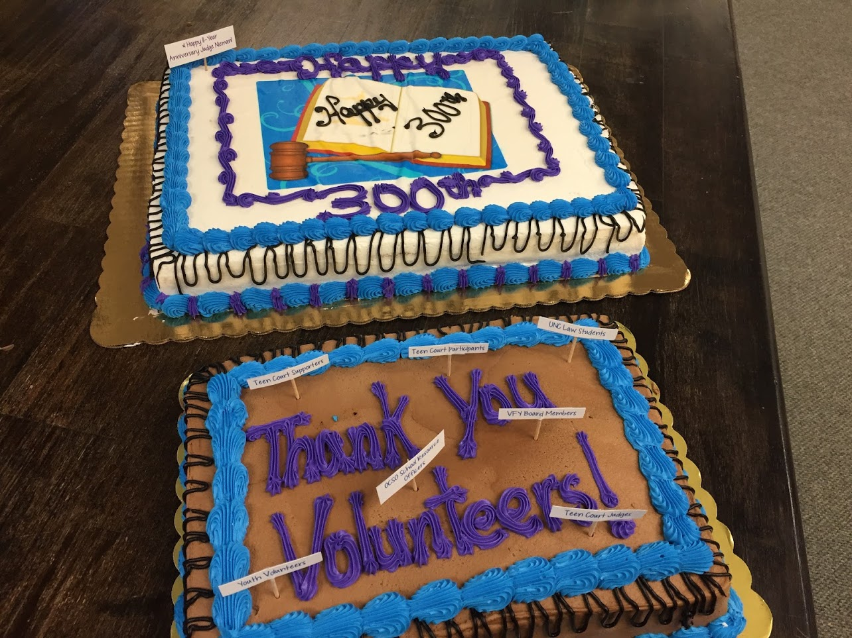
Staff
Susan Prothro Worley, Executive Director
Scott Dreyer, Community Service and Restitution Coordinator Madison Bennett, Youth Services Coordinator
Jamella Smith, Teen Court Coordinator
Abby Gillis and Aidan Spelbring, Bonner Leaders

w w w . v o l u n t e e r s f o r y o u t h . o r g

205 Lloyd Street, Suite 103, Carrboro, NC 27510

